Student’s Name
Professor’s Name
Course
Date of Submission
Lab 3: Types of weathering
- Biological weathering
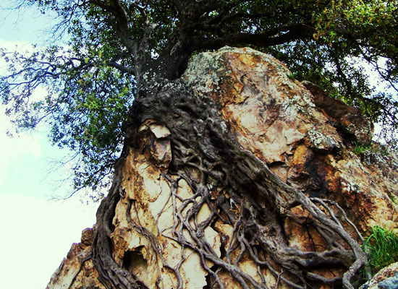
Biological weathering takes place when rocks are broken down by living organisms. In this picture depicting biological weathering, some trees have grown in the rock, extending their roots through it to cause cracks. The cracks have widened and become much deeper as the roots penetrate through it. As a result of the roots penetration, part of the rock has split off from the parent rock leaving the roots engraved on the parent rock and the slip rocks falling off to the surrounding ground.

- Chemical weathering
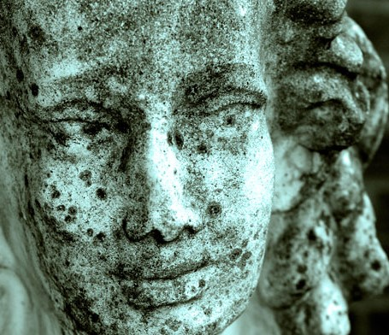
The picture above depicts a chemical weathering of a limestone statue. The statue is eroded at an extensive level due to the stone’s chemical properties that makes it susceptible to chemical reactions. There is high chance that the statue stone has been eroded by rain water due to its widespread damage. When a fossil like gasoline is burnt, it releases green gases into the atmosphere which combines with water vapor to form carbonic acid. Therefore, when it rains, water acidic water reacts with the limestone and it gets corroded.
- Physical weathering
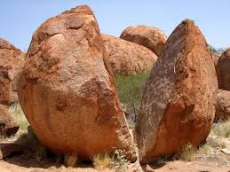
This picture depicts a physical weathering in which one large rock has been broken down into two parts. The rock has split into two due to the temperature change. Hot temperature results in t expansion of rocks. However, cold temperatures make the rock to shrink. The continuous process of the rock expanding and contracting has led to the crack. Another possible cause of the crack is freeze-thaw. Water expands when it freezes and flows further and faster when it melts thus water may have frozen in the rock to make it expand and crack.

